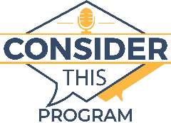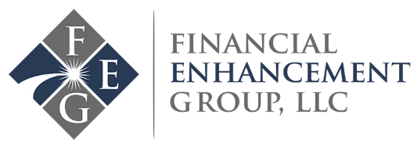

Consider This Program: September 5th, 2020
Divorce and Your Taxes with Host Joe Clark, CFP and Co-Host Angi Kinser
If you are divorced or are in the process of having your divorce, you need to know what the taxman expects of you. Our host Joe Clark and co-host Angi Kinser, will discuss divorce and taxes, among other informative topics.
How do you define yield in the investment world? Joe and Angi will be digging deeper into this topic to help us understand the definition of yield in the investment context, what causes the yield to change and what drives change in yield to maturity.
Cryptocurrency is slowly gaining popularity, and we cannot afford to hide under a rock without understanding how it works and how it will affect the world. Angi and Joe will give us an overview of cryptocurrency and blockchain technology.
Listen in to this informative episode and learn.
Key Talking Points of the Episode:
- The average retirement age in the US
- Yield in the investment world
- Taxes and divorce
- Qualified Charitable Distributions (QCD)
- Cryptocurrency and blockchain technology
Key Milestones of the Episode:
[01:50] Angi’s Trivia: What’s the average age for retirement in the US?
[04:21] Joe’s trivia
[05:39]What is yield in the investment world?
[19:50] Divorce and taxes
[30:18] Qualified Charitable Distributions (QCD)
[43:04] Cryptocurrency
Questions answered in the episode:
[09:08] What causes the yield to change?
[12:28] When looking at 401k allocation options, it says the bond funds have average returns over one year, five years, and ten-year terms. Does the yield affect these returns? How are these returns calculated?
[14:46] What causes a change in yield to maturity?
[19:50] What are your filing status choices after going through a divorce?
[21:19] How can you file for head of household?
[22:01] Should you report child support or alimony on the tax return?
[23:22] What proof do you need to submit for a divorce?
[25:50] What’s divorce like for empty nesters when it comes to taxes?
[27:19] What is a QDRO (qualified domestic relations order)?
[30:17] Should you still use QCDs even if you are not required to take your required minimum distributions?
[39:02] What is the difference between itemizing gifts to charity versus says using QCDs to gift?
[47:23] What’s blockchain?
Key Quotes from the Episode:
“When you’re looking at the tax code, the best way to think about it is as a series of stair steps.”
“Just because somebody says you can do something doesn’t necessarily mean it’s in your best interest.”
“Every time you put money in your 401k, you said no to something else.”
“The worst money for you to inherit or for you to leave behind to a human is deferred tax money because they have to pay taxes on it even if you don’t.”
Connect with Financial Enhancement Group:
Visit our Facebook page at www.Facebook.com/FinancialEnhancementGroup

Join our Facebook Group at www.yourlifeafterwork.com/FinancialTidbits

Visit our website at www.yourlifeafterwork.com

We would love to answer your questions on air!
Call Angi at (800) 928-4001 or send them to TalkToFEG@yourlifeafterwork.com
On the 10th of September, we're doing a complimentary critical tax decisions lecture that you can attend. Also, starting from 15th to 17th of September, Joe is going to teach a very condensed workshop over the five critical elements. For 90 minutes every day starting at 7:00pm to 8:30pm. To register call Angi at (800) 928-4001 or visit our website www.yourlifeafterwork.com

